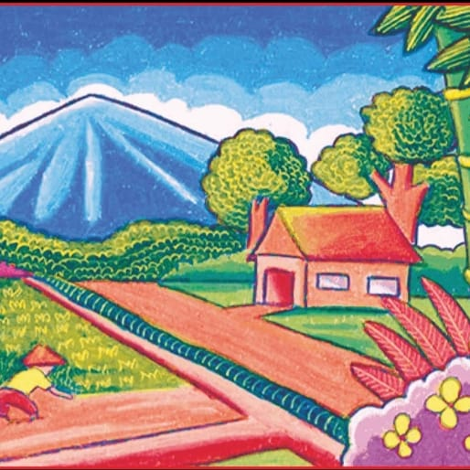

Caption : Such beautiful natural landscape must be taken car of at least cared for and cleaned because beautiful nature will be good for health.